CODEALPHA Internship
- P M Athavur Rahman
Task – 1 Web Scrapping

Key Takeaway: Learned how to extract database or how to collect data from websites ,
● Use Python libraries like BeautifulSoup or Scrapy to extract data from websites.
● Identify and collect relevant datasets from public web pages.
● Learn to handle HTML structure and web navigation to gather accurate data.
● Create custom datasets tailored to specific analysis needs.
Outputs:
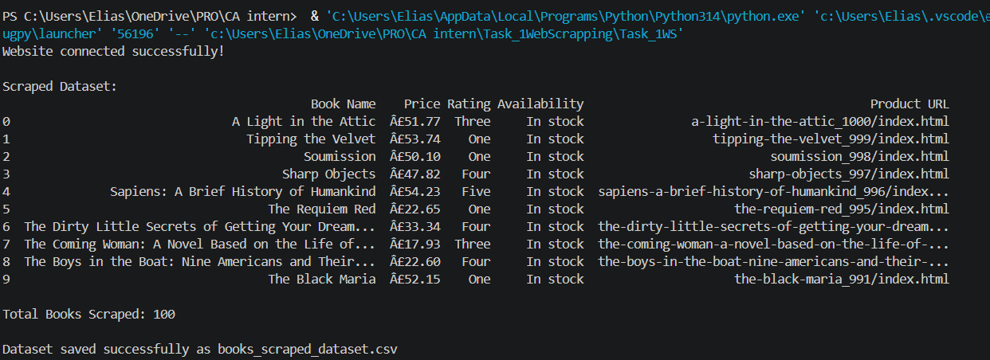
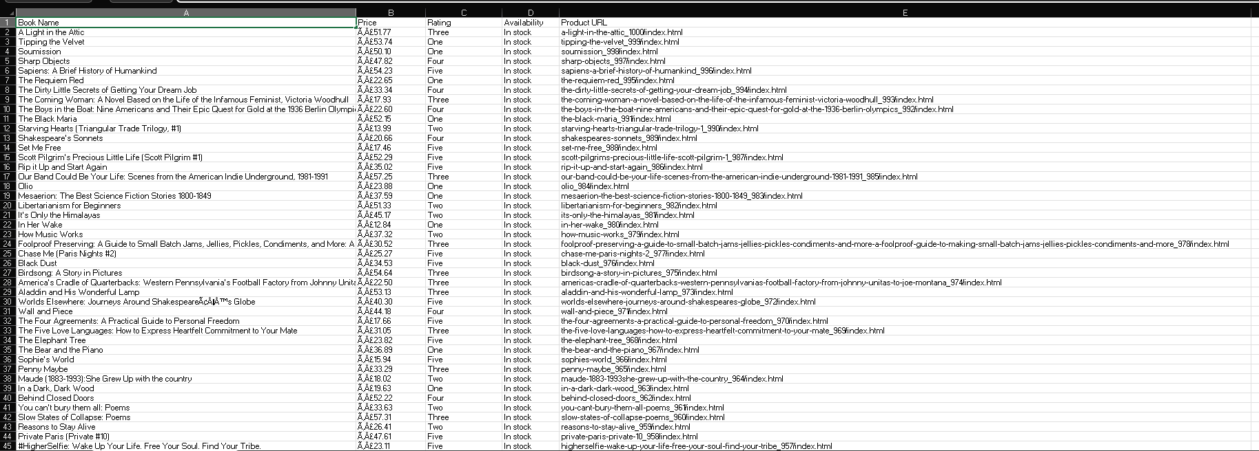
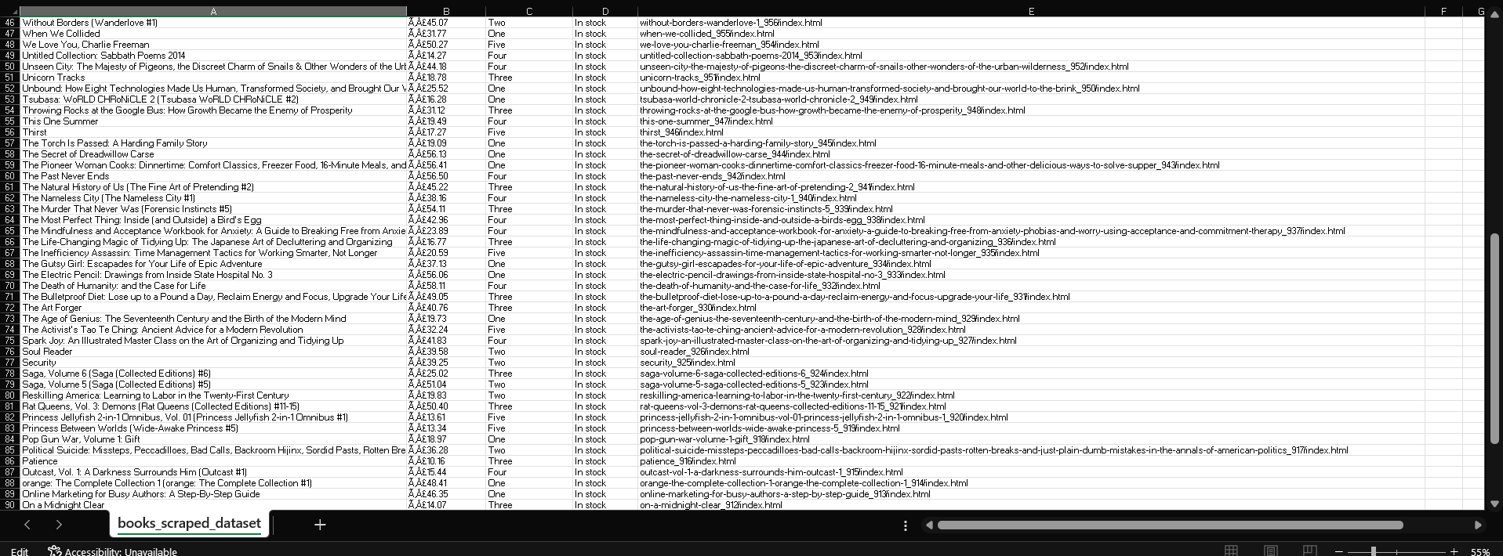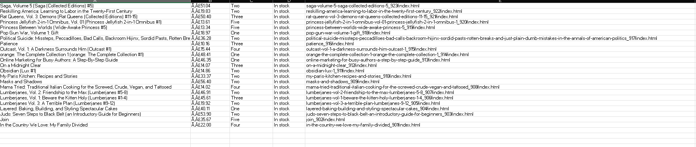

Task – 2 Exploratory Data Analysis
Key Takeaway : Basic insights of data clean and and preprocessing ,Further how to :
● Explore the data structure, including variables and data types.
● Identify trends, patterns and anomalies within the data.
● Test hypotheses and validate assumptions using statistical assumptions
Output:
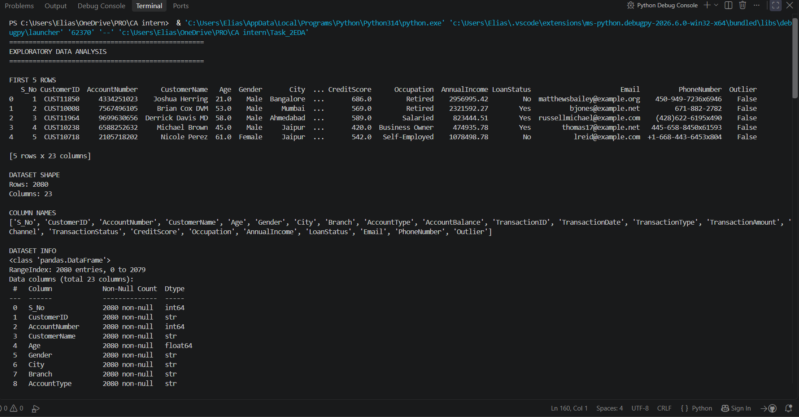
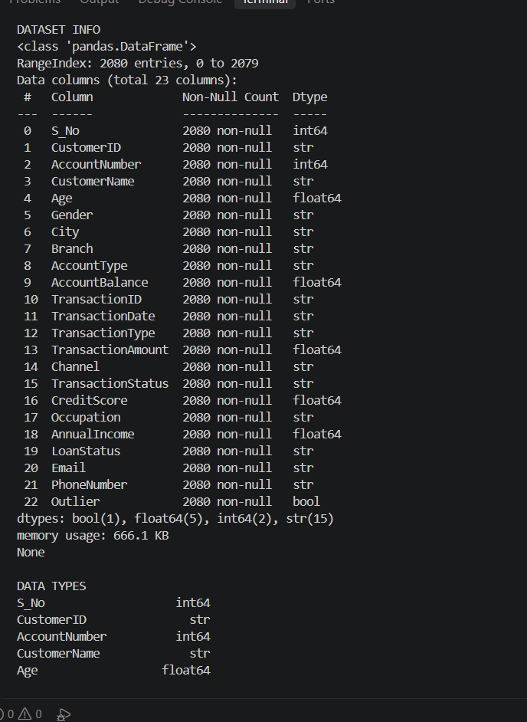
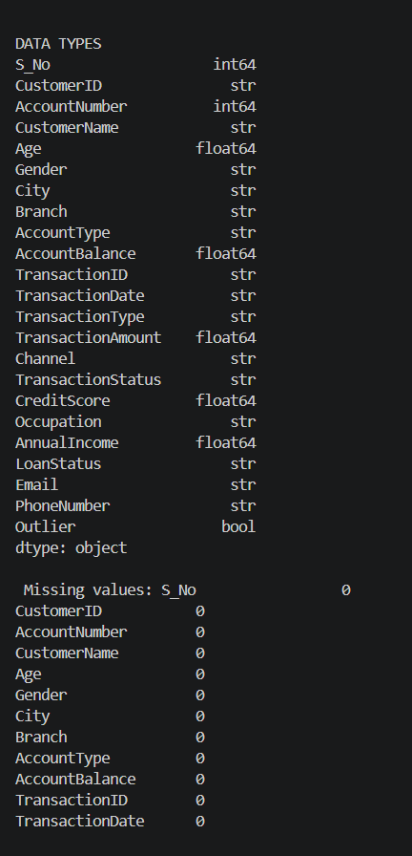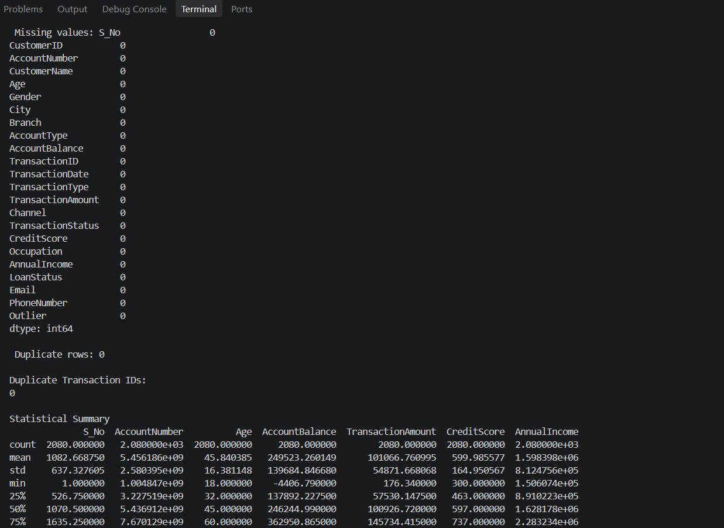
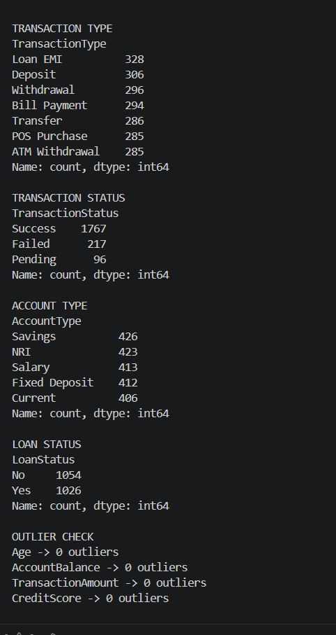
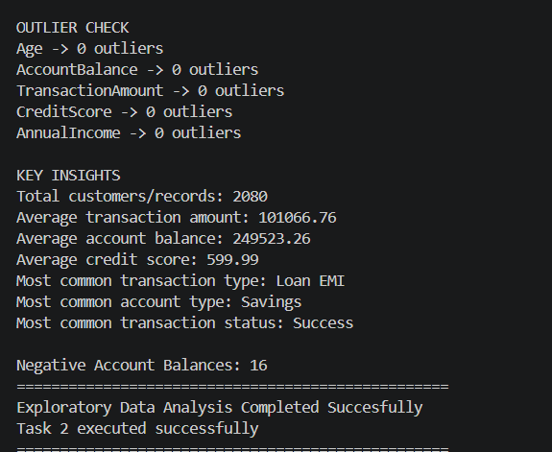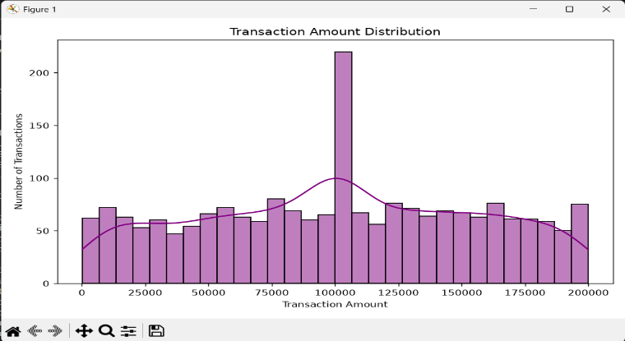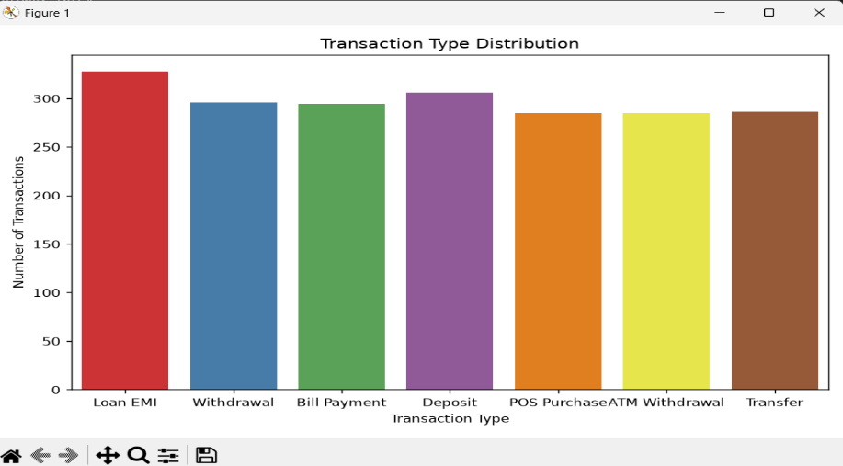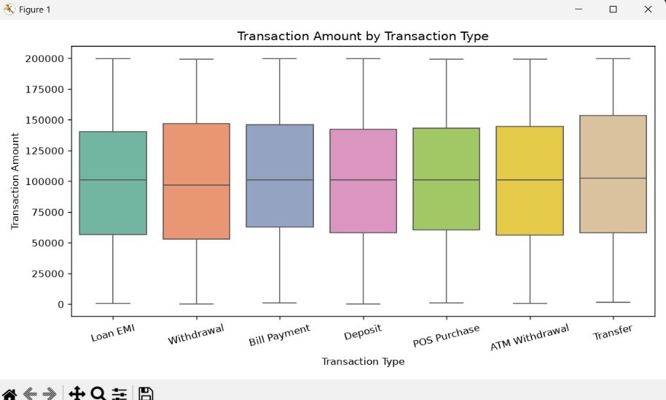

Task – 3 DATA VISUALISATION
Key Takeaway : Learned How to use python libraires for data visualization techniques using Pandas, Matplotlib, Seaborn which provide beautiful visuals using loaded dataset
● Transform raw data into visual formats like charts, graphs, and dashboards.
● Use tools like Matplotlib, Seaborn, or Tableau for creating visuals.
● Design visuals that enhance understanding and reveal insights clearly
Visuals Created : Heatmap, correlation matrix, boxplot, counter plot, etc…
Output:
